BIO-DATA
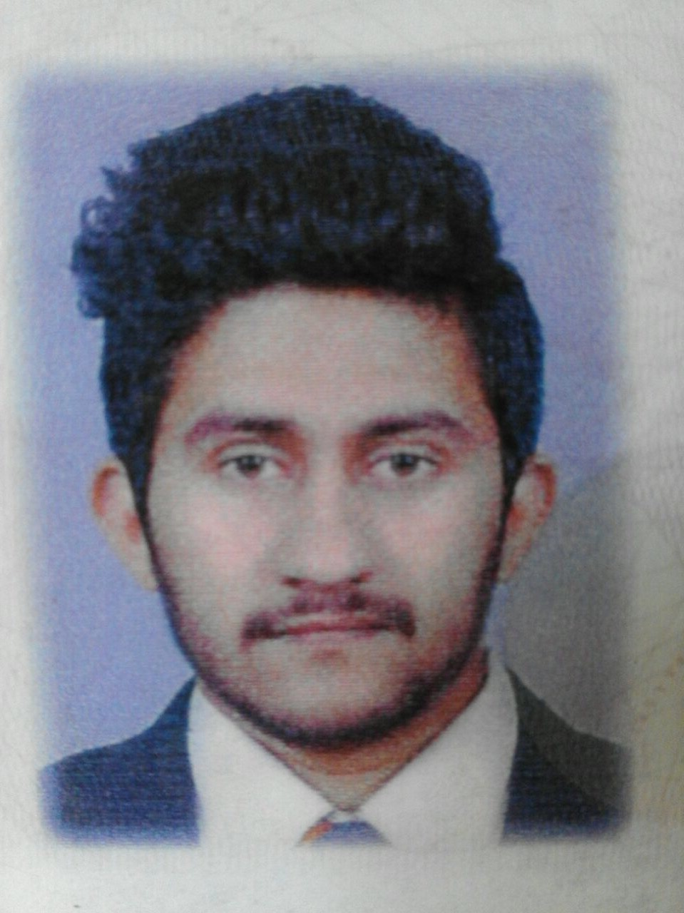

Jegathees Barath Prasanna.

email:Badbarathboy@gmail.com

Ph: +94 750905631

PERSONAL STATEMENT

To obtain a career with an organization, that provides a good opportunity for the growth. I can work with all my ability and will work under a Task oriented management taking upon work pressures and complete the works with high responsibility.

TECHNICAL SKILLS

- Operating systems and Software: Windows XP/Vista/7/8, Windows server 2003, 2008.
- Tools: Team Viewer, Ammy.
- Security: Mc Afee, Norton Antivirus, Kaspersky, Bit Defender
- Office Suits: MS Office, Open Office.

PROFESSIONAL HIGHLIGHTS

- Competitive Spirit and a passion for innovative ideas.
- A good knowledge on different airline operations and their features.
- A good communication skill.
- Work effectively with self-motivation.
- Adaptation to any environment.

TRAINING EXPERIENCE

- In Graphic designer in Tele-pix as a designer.

EDUCATIONAL QUALIFICATIONS

- Completed Ordinary Level Examination (Year 2008)
Studied School:- Kathiresan Central College, Nawalapitiya.
Medium of Study: Tamil

Results:

Subject | Grade
Tamil | C
English | S
Mathematics | B
Science | S
History | S
Religion | C
Art | C
Commerce | B
Health & Science | A

➢ Diploma in Graphic Designing from E-Soft in nawalapitiya 2013 batch.

➢ Diploma in M.S.Office from E-Soft (Nawalapitiya) 2012 batch.

AREA OF INTERESTS

➢ Accounting.

➢ Sales and marketing.

➢ Graphic designing.

➢ Cashier.

➢ Media.

EXTRA ACTIVITIES IN SCHOOL

➢ Mega art competition.

➢ Island annual art competition.

➢ Captain of school and College Cricket team (Hard ball.)

➢ Art competition &amp; Sri Lanka Exhibition and Convention.

➢ Participated in school and College sports competitions.

SEX

➢ Male

MARITAL STATUS

➢ Unmarried

DATE OF BIRTH

➢ 12/05/1992 (dd/mm/yyyy)

NATIONALITY

➢ SRI LANKAN

LANGUAGES KNOWN

➢ Tamil, English & Sinhala.

NATIONAL IDENTITY CARD No:

➢ 921334486V

PASSPORT NO:

➢ N6563742

REFERENCE

Mr. C. Rajendran,
Principal,
Kathiresan Central College Nawalapitiya.
Ph: .

Declaration:

I do hereby certify that above particulars furnished by me are true and correct to the best of my

knowledge. I will discharge the duties entrusted to me to the best of my ability

………………………… …………………………….

Date Signature

